**Exercise 3: Assertions in Junit**

**Scenario:**

You need to use different assertions in JUnit to validate your test results.

**Code:**

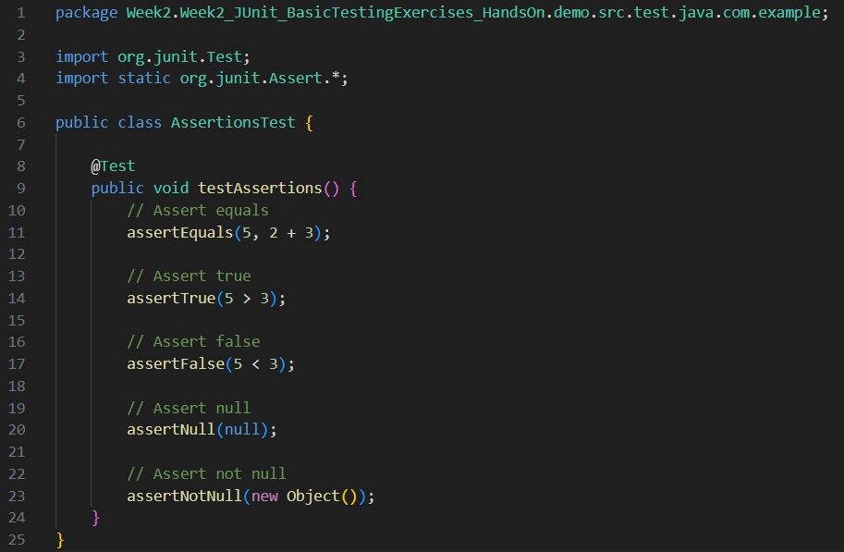

**Output:**

